**AMERICAN INTERNATIONAL**

**UNIVERSITY-BANGLADESH**

**Assignment Cover Page**

|  |  |  |  |  |
| --- | --- | --- | --- | --- |
| Assignment Title: | Selenium Downloads and Test Case | | | |
| Assignment No: | 01 | | Date of Submission: | 7 November 2022 |
| Course Title: | Software Quality and Testing | | | |
| Course Code: | CSC4271 | | Section: | B |
| Semester: | Fall | 2022-23 | Course Teacher: | ABHIJIT BHOWMIK |

**Declaration and Statement of Authorship:**

1. I/we hold a copy of this Assignment/Case-Study, which can be produced if the original is lost/damaged.
2. This Assignment/Case-Study is my/our original work and no part of it has been copied from any other student’s work or from any other source except where due acknowledgement is made.
3. No part of this Assignment/Case-Study has been written for me/us by any other person except where such collaborationhas been authorized by the concerned teacher and is clearly acknowledged in the assignment.
4. I/we have not previously submitted or currently submitting this work for any other course/unit.
5. This work may be reproduced, communicated, compared and archived for the purpose of detecting plagiarism.
6. I/we give permission for a copy of my/our marked work to be retained by the Faculty for review and comparison, including review by external examiners.
7. I/we understand thatPlagiarism is the presentation of the work, idea or creation of another person as though it is your own. It is a formofcheatingandisaveryseriousacademicoffencethatmayleadtoexpulsionfromtheUniversity. Plagiarized material can be drawn from, and presented in, written, graphic and visual form, including electronic data, and oral presentations. Plagiarism occurs when the origin of them arterial used is not appropriately cited.
8. I/we also understand that enabling plagiarism is the act of assisting or allowing another person to plagiarize or to copy my/our work.

*\* Student(s) must complete all details except the faculty use part.*

** Please submit all assignments to your course teacher or the office of the concerned teacher.

|  |  |
| --- | --- |
| Group Name/No.: |  |

|  |  |  |  |  |
| --- | --- | --- | --- | --- |
| **No** | **Name** | **ID** | **Program** | **Signature** |
| 1 | **OISHI SINGH** | 20-43067-1 | Bsc CSE | oishi |
| 2 | **ANIK DEBNATH** | 20-42780-1 | Bsc CSE | anik |
|  |  |  |  |  |
|  |  |  |  |  |

*Table of Contents*

**Part-I: Installation Process of Selenium Webdriver for Web Application Automation Testing.** 3

**Flowchart of Installation Process** 3

Visual Representation and Description of Each Step of the Flowchart 4

Download and Install Java Development Kit (JDK) 4

Configure Environment Variables for JDK 6

Download and Install Eclipse IDE for Java Developers 9

Download Selenium 12

Download Chromedriver for the Chrome Browser 13

Configure Selenium on the Eclipse 14

**Part-II: Test a Web Application Module Using Selenium Webdriver.** 21

**Flowchart of Testing Process** 21

Visual Representation and Description of Each Step of the Flowchart 22

Create a New Project in Eclipse IDE 22

Select a Web Application Module Which Will be Tested 22

Prepare a Test Case 22

Write Required Code 23

Run and Observe the Outcomes 26

**What is Selenium:** Selenium is basically used to automate the testing across various web browsers. It supports various browsers like Chrome, Mozilla, Firefox, Safari, and IE, and we can very easily automate browser testing across these browsers using Selenium WebDriver.

**PART-1 The Selenium Web driver installation procedure for testing web applications automatically.**

## **Flowchart of Installation Process**

Download and Install Java Development Kit (JDK)

Configure Environment Variables for JDK

Download and Install Eclipse IDE for Java Developers

Download Selenium

Download Chrome driver for the Chrome Browser

Configure Selenium on the Eclipse

**Download and install the Java Development Kit. Visual Representation and Description of Each Step in the Flowchart (JDK)**

1.For downloading the Java Development Kit (JDK) you need to click on that link. This is only for windows users. For macOS and Linux there are also available links on the website.

(<https://download.oracle.com/java/19/latest/jdk-19_windows-x64_bin.exe>)

2.The necessary file will then begin downloading after that.

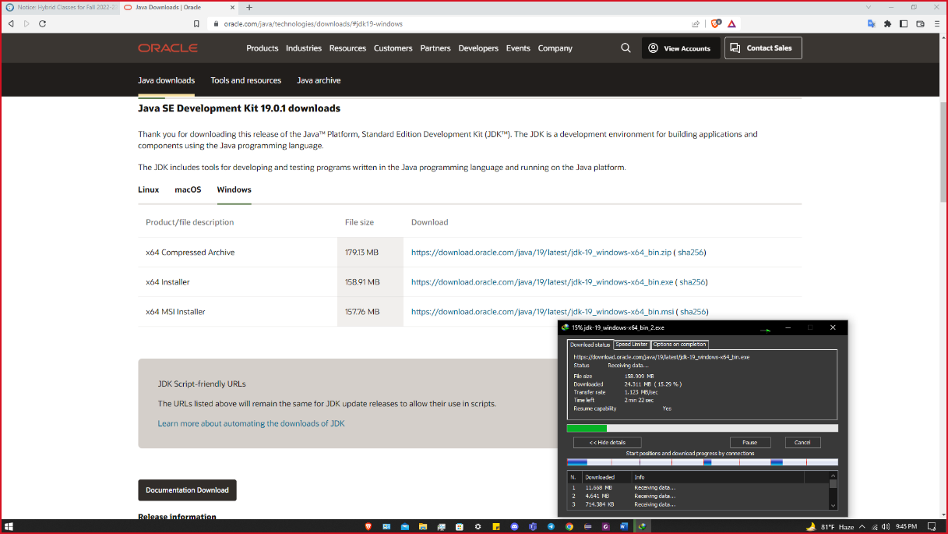

3. After successful downloading open the file.

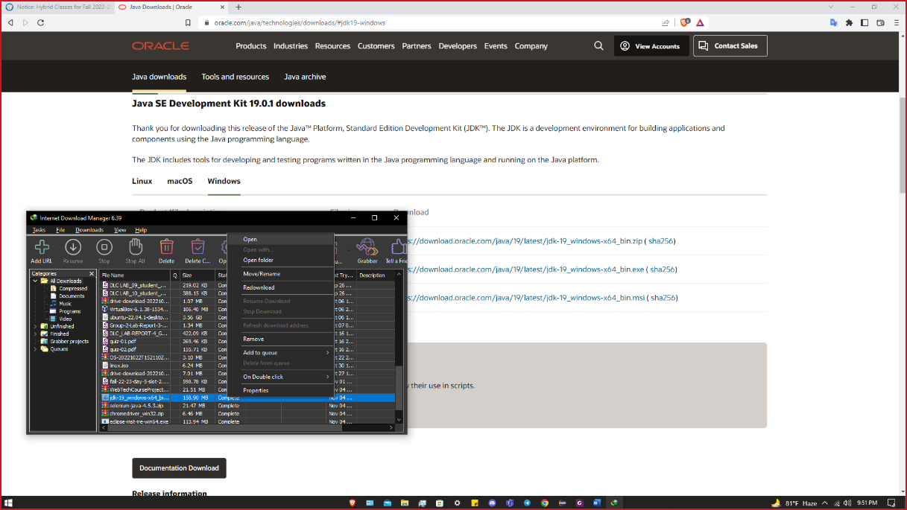

4.After open this file we can able to see this interface and click on the **Next** option.

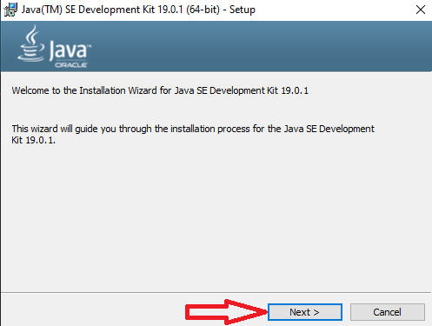

5.Again, click on the Next option.

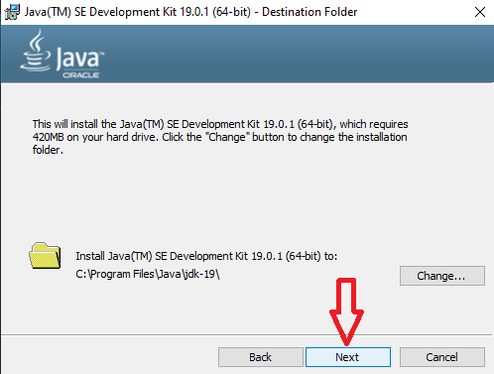

6. Wait some moment for further process.

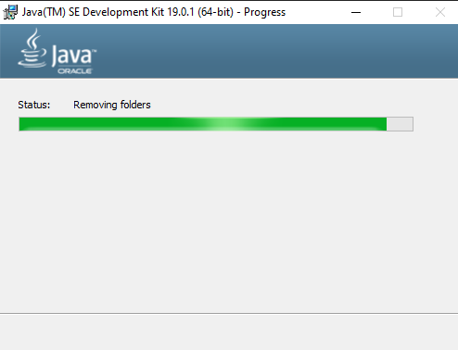

7.After all processes click on **Close** option.

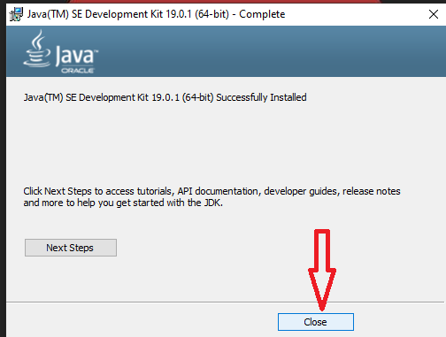

8.So far, our installation process is finished.

### **Configure Environment Variables for JDK**

1. After installation we can find our required Java file in this location.

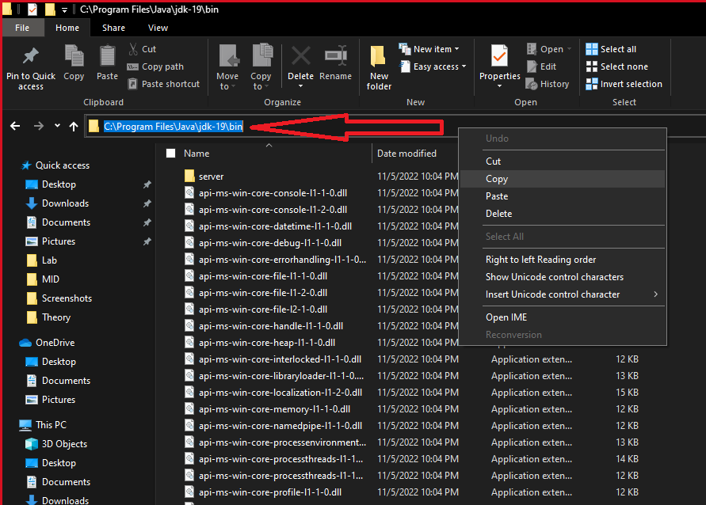

2.Then we need to go to **Settings → System → Search System environment** and Click on **Edit the system environment** option.

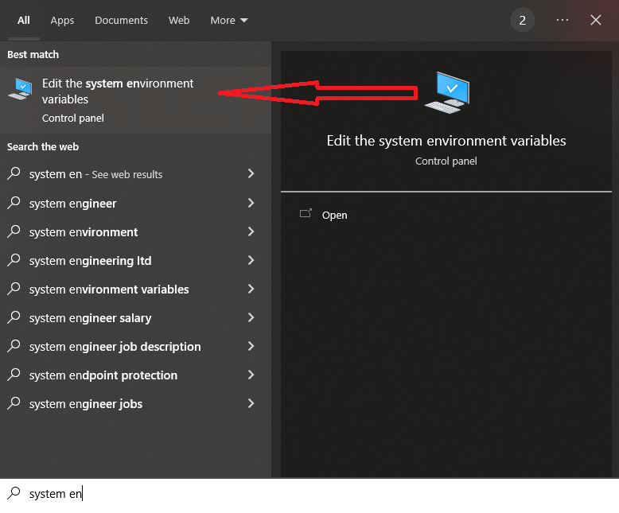

3. Then we can see this interface and click on the **Environment Variables** option.

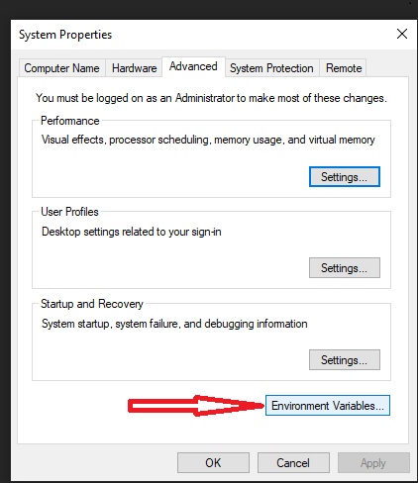

4. Click on **New** option.

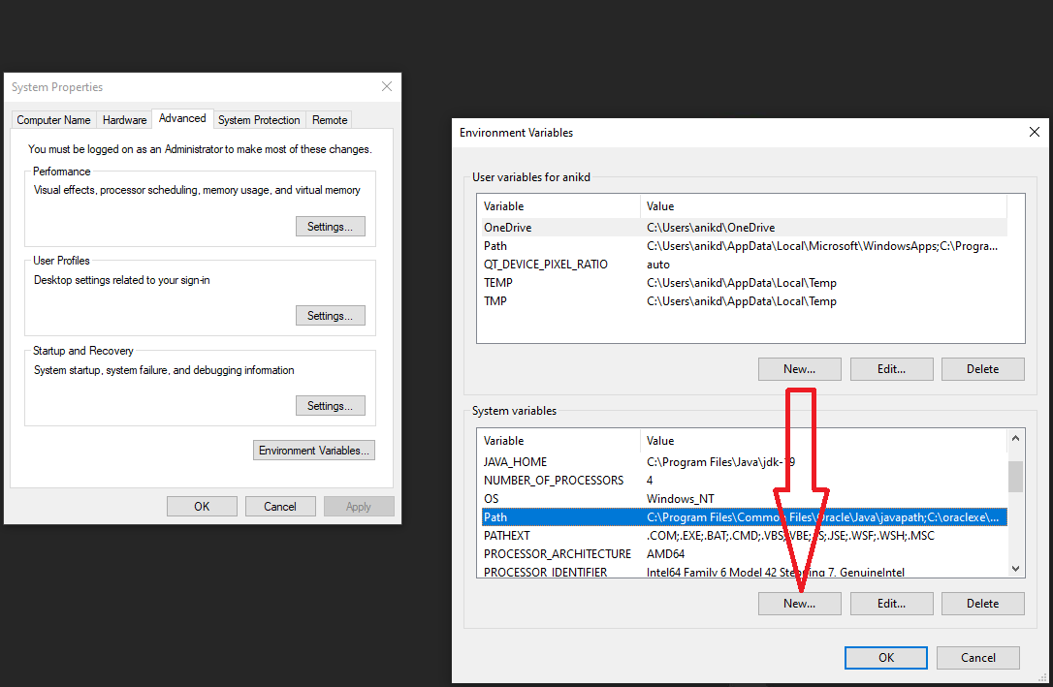

5. Then set the Variable Name as JAVA_HOME or what you want. And paste location path of the installed JDK folder. (C:\Program Files\Java\jdk-19.0.1). Then click on **OK** in all the tabs.

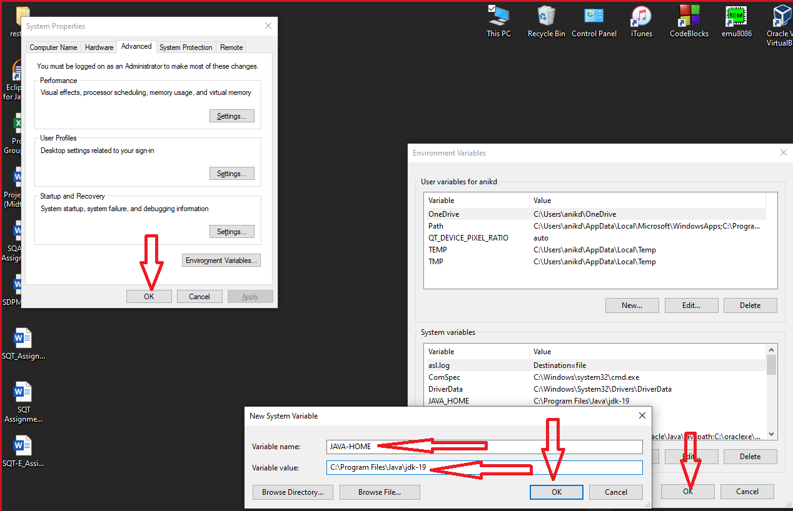

6.Now we check that our JDK environment variable properly set or not using the Command Prompt. Open the Command Prompt and write **java -version**. If we can see this kind of text after execute the command then our process is successful.

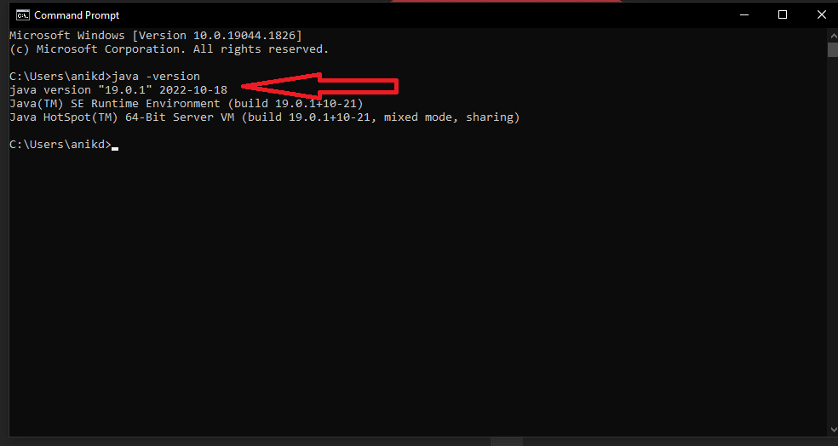

### **Download and Install Eclipse IDE for Java Developers**

1.For downloading the Eclipse IDE for Java Developers, you need to click on that link. This is only for windows users. For macOS and Linux there are also available links on the website.

(https://www.eclipse.org/downloads/download.php?file=/oomph/epp/2022-09/R/eclipse-inst-jre-win64.exe)

2.Then the required file will start downloading.

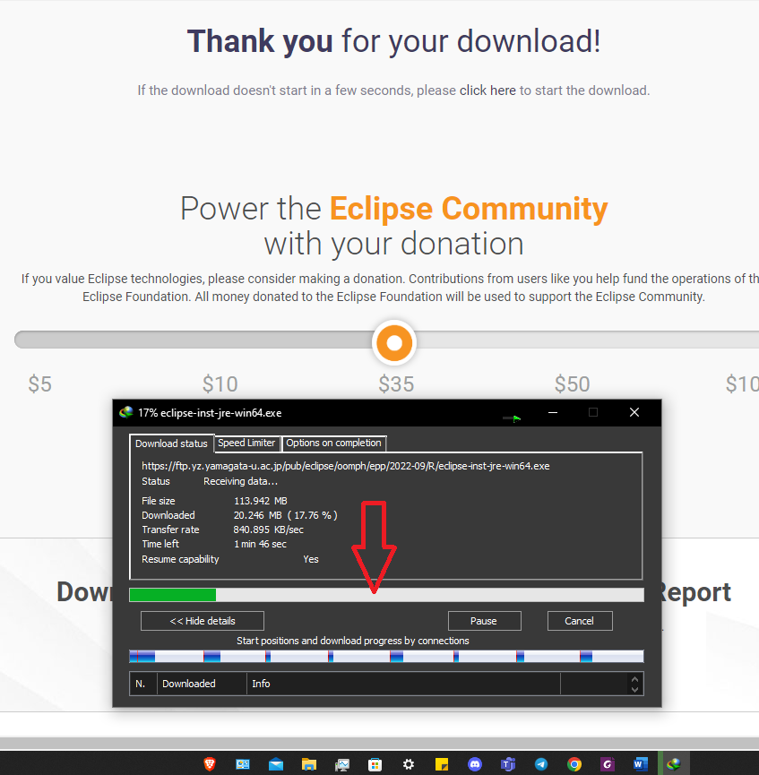

3.After successful downloading open the file.

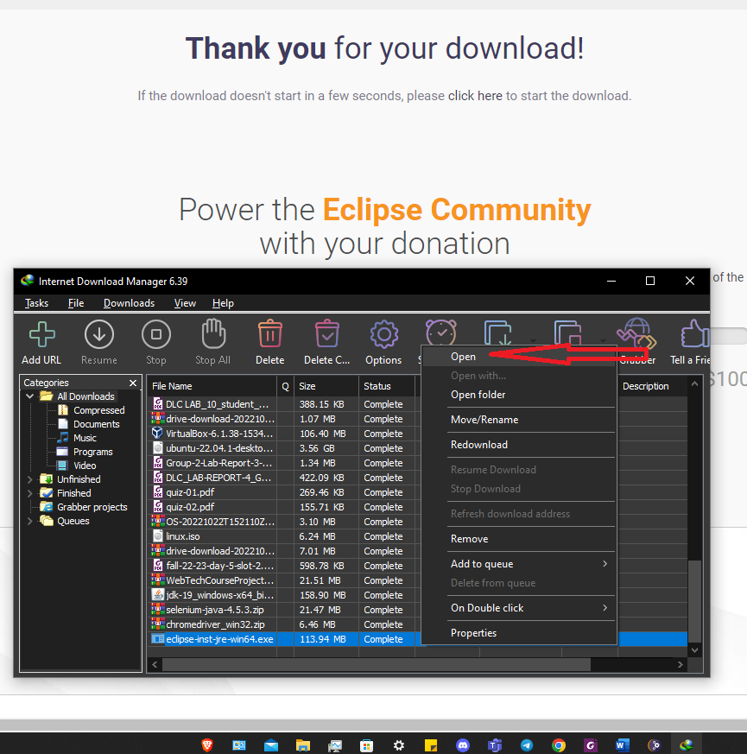

4. After that we can see this tab and click on the first option.

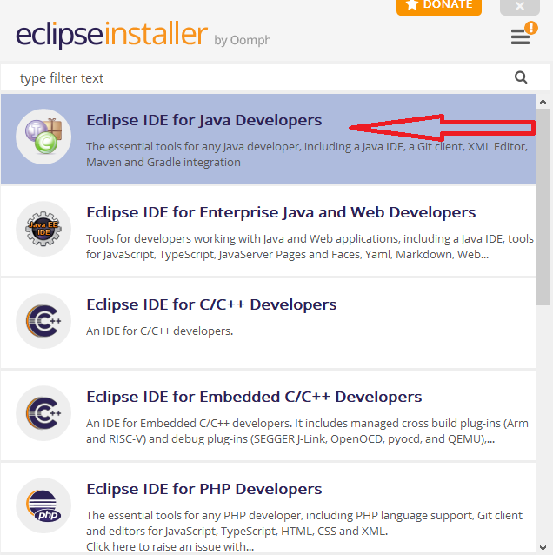

5. Click on the **Install** option.

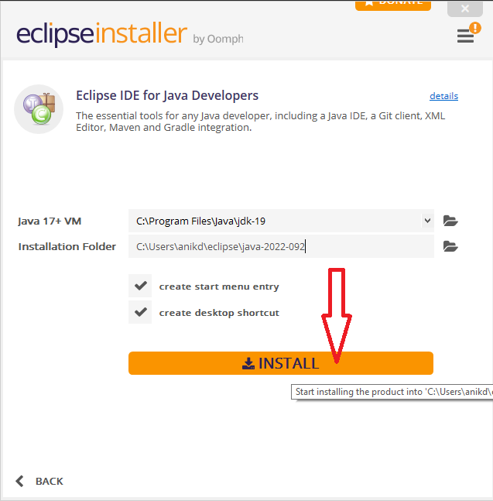

6. Wait some moment for further process.

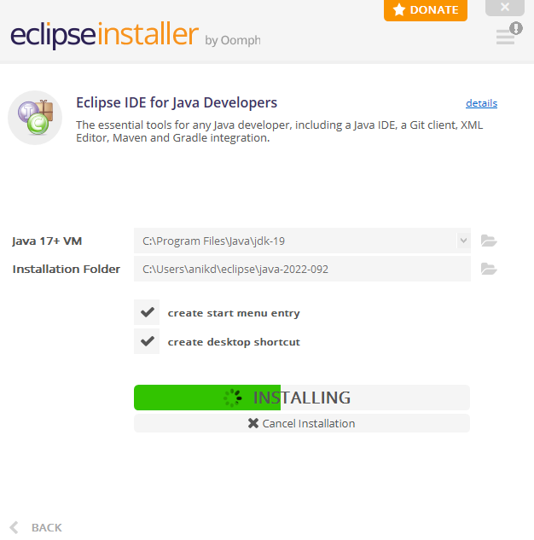

7. Click on the **LAUNCH** option.

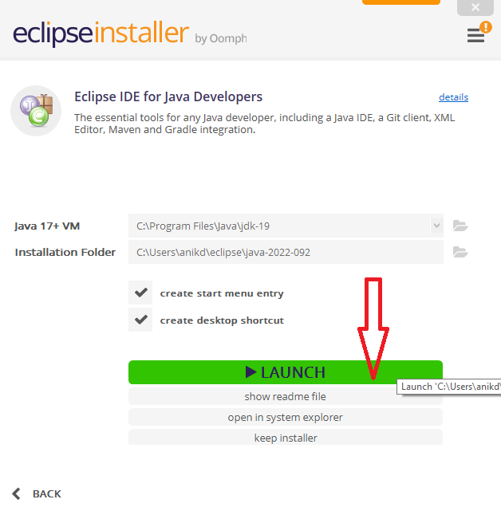

8.Again, select the **Launch** option here to open the Eclipse IDE.

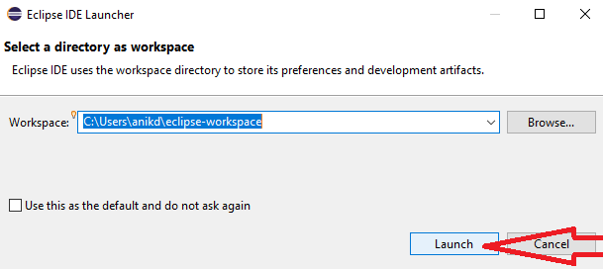

9. After that, we can able to see this window. That’s mean our Eclipse IDE is ready for work and our configuration procedure finished.

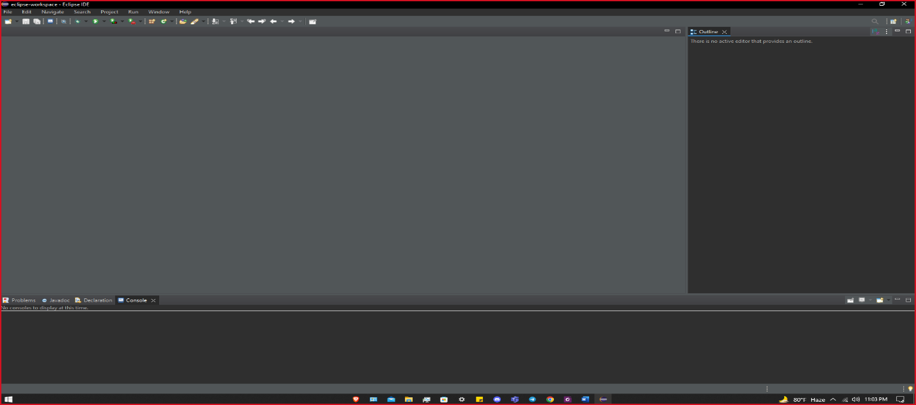

### **Download Selenium**

1.For downloading the Selenium Web driver you need to click on that link.  
(<https://www.selenium.dev/downloads/>). Select **Latest stable version 4.6.0 option**. Required file start downloading.

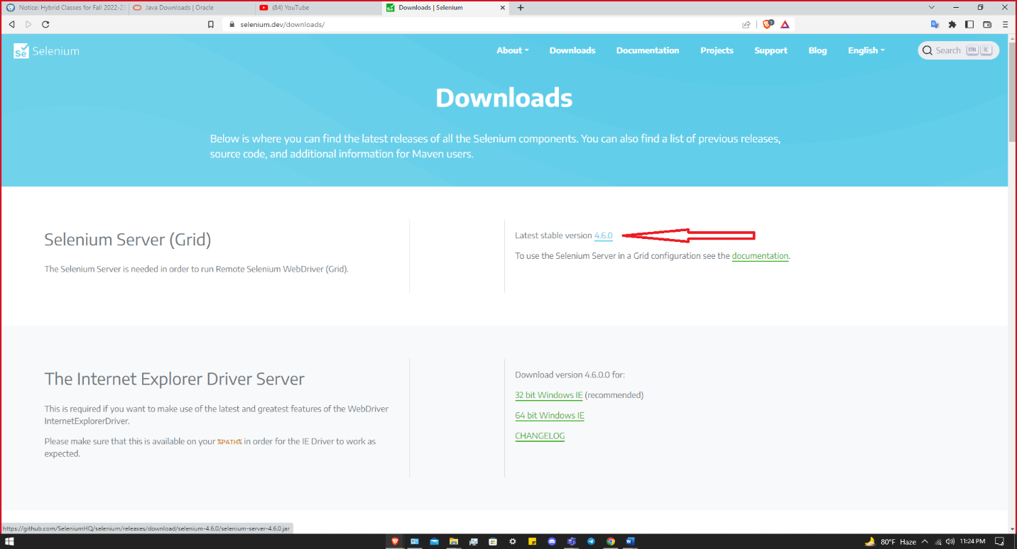

**Download Chromedriver for the Chrome Browser**

1.For downloading the Chromedriver you need to click on this link.  
(<https://chromedriver.chromium.org/downloads>). Then find the version which will match with your Chrome Browser latest version.

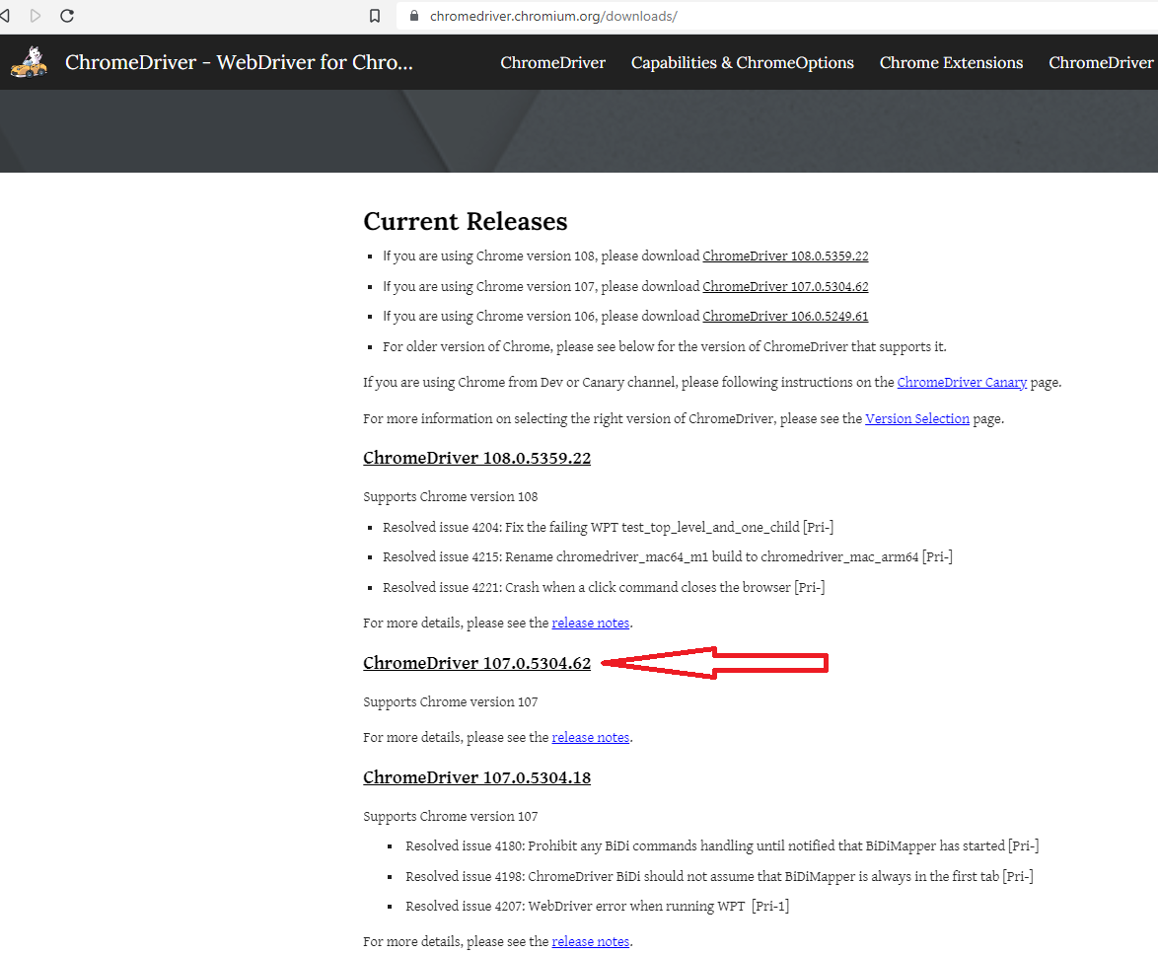

2. Then you can see this page. Click on the link which is according to your Operating System. I click on **chromedriver_win32.zip**. Because I use Windows Operating System. Then the required file will start downloading.

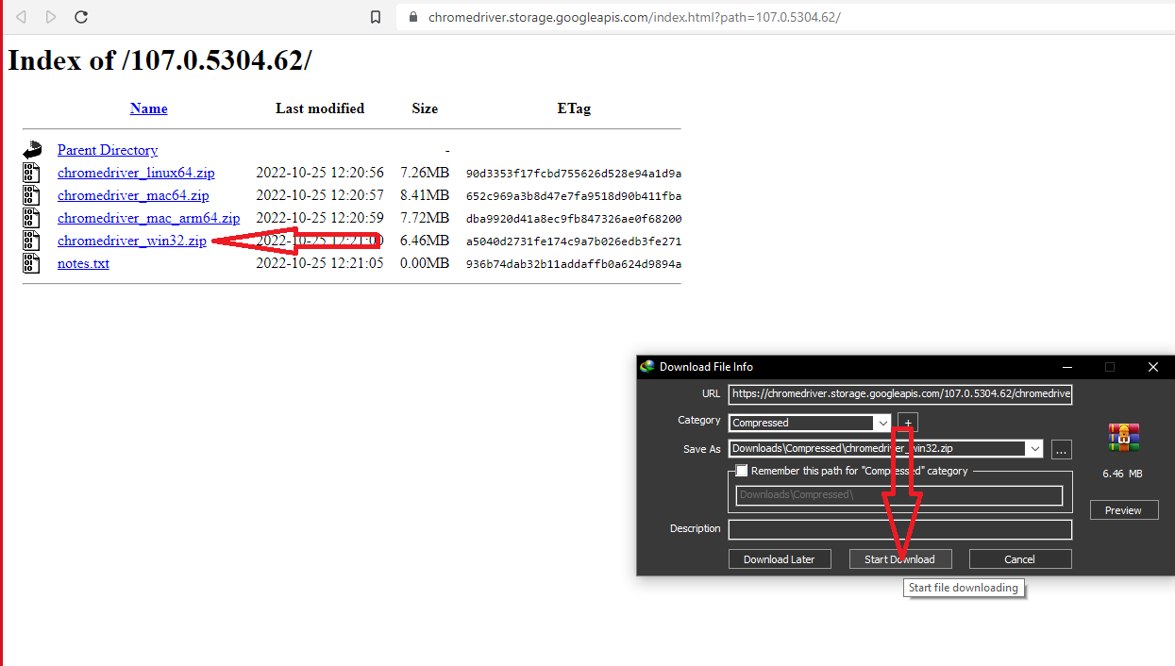

**Note:** If you use different browser then you need to download the driver according to your browser.

### **Configure Selenium on the Eclipse**

1.For our working convenience, we will keep the Selenium and Chromedriver file in the same folder which we already downloaded in our previous steps. In that case, I created a folder as Selenium in **C Drive**. Then keep those files inside that folder.

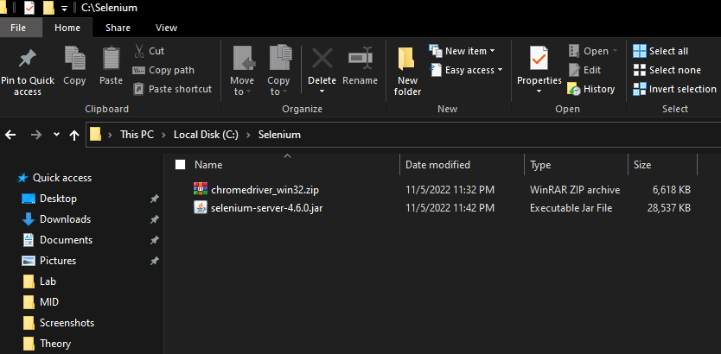

2. Now we run the Eclipse IDE for configure the Selenium

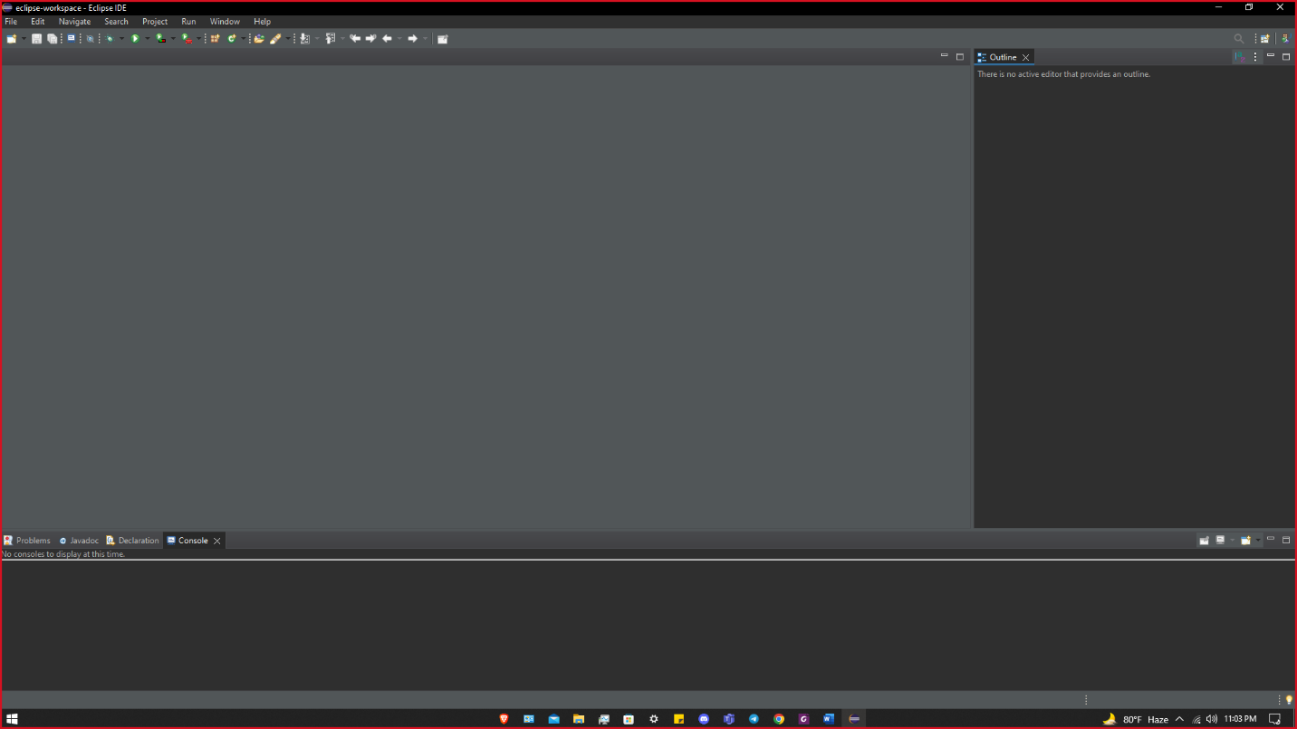

3.For create a new java project. Click on **File → New → Java Project**.

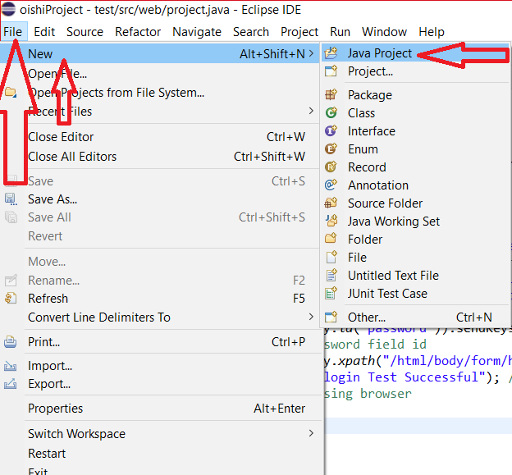

**4.** Then this tab will appear. Give the **Project Name** as your choice. Then click on that dropdown option and select **JavaSE-1.8** and click on **Finish**.

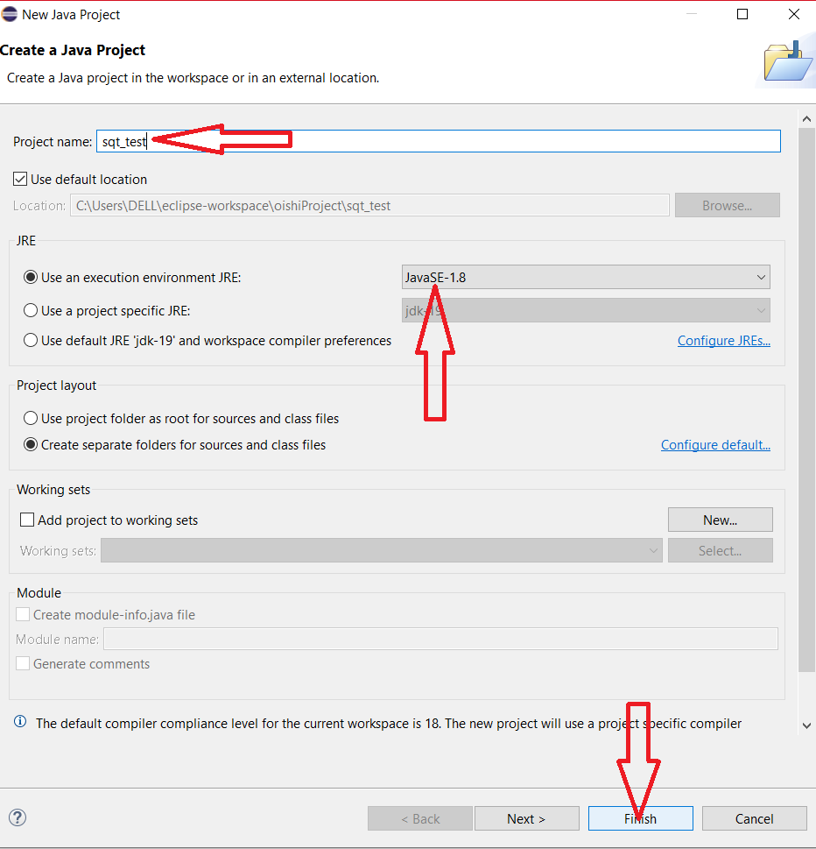

5.Then right click on the project name. Click on **Bulid Path → Configure Build Path** option.

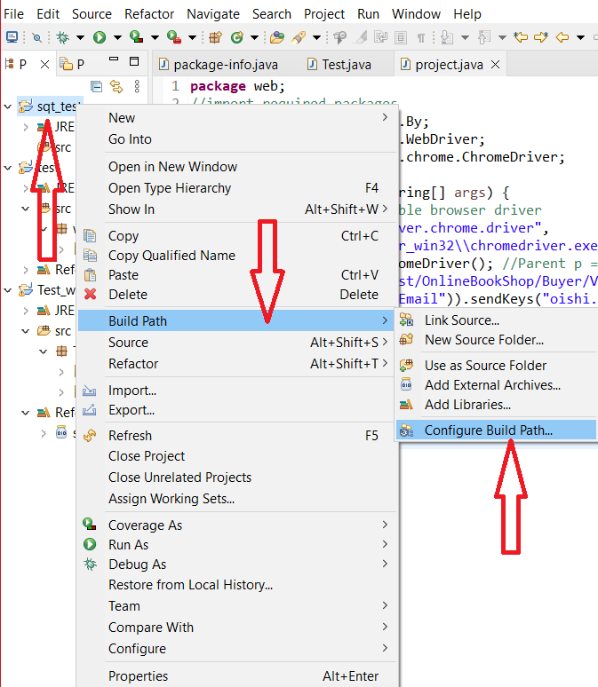

6.Then this tab will appear to us. Then go to **Libraries → Add External JARs…** option Then go to that path here we stored our Selenium file then select the file, click on **Open** then click on **Apply and Close**.

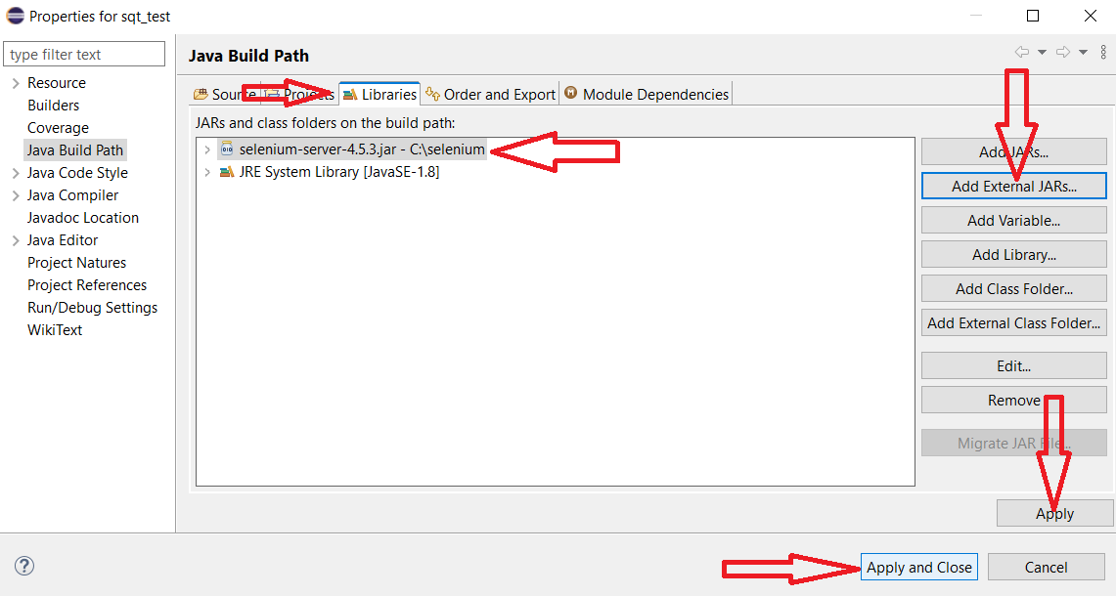

7.Now right click on **src** option then click on **New → Package**.

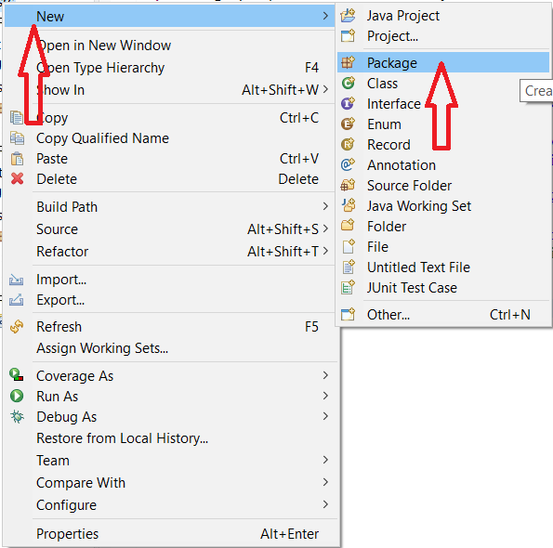

9.Then this tab will appear. Give a name and click on **Finish**.

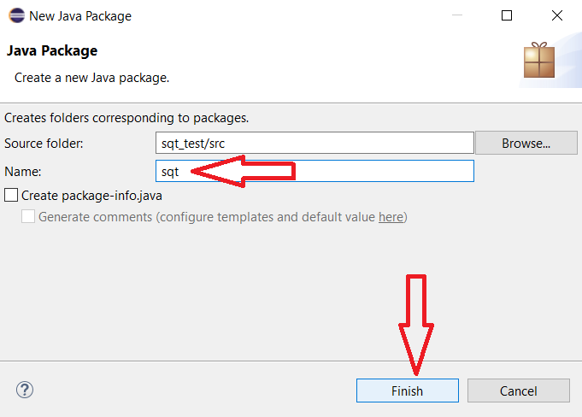

10.After that, click on **sqt** option then **New → Class**.

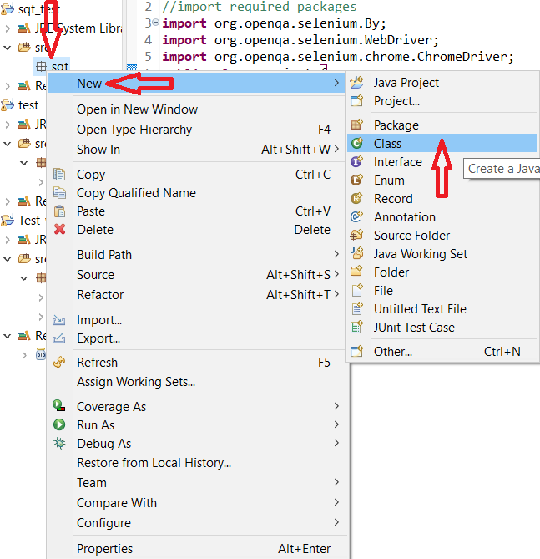

11. Give a name of **Package section**. Give a class **Name** Click on **Finish**.

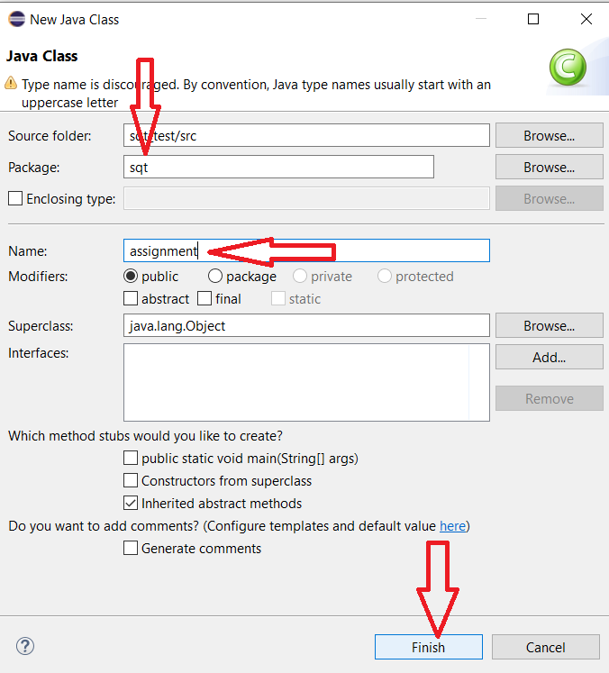

12. Ultimately this window will visible to us. That’s mean our Selenium configuration on Eclipse IDE is done.

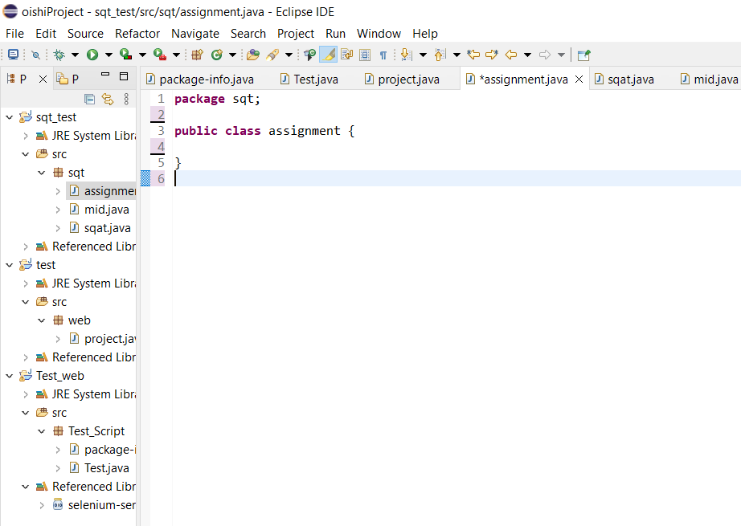

# **Part-II: Test a Web Application Module Using Selenium Webdriver.**

## **Flowchart of Testing Process**

Run and Observe the Outcomes

Write Required Code

Create a New Project in Eclipse IDE

Select a Web Application Module Which Will be Tested

Prepare a Test Case

### **Visual Representation and Description of Each Step of the Flowchart**

### **Create a New Project in Eclipse IDE**

1.In **Part-I**, **Configure Selenium on the Eclipse** section’s (ii-xiii) points already explained this procedure. Kindly look over that section then you can easily create a new project in Eclipse IDE.

### **Select a Web Application Module Which Will be Tested**

1.For testing purposes, we select a web application **“Online Book Shop Management System”** that I did in my **“Web Technology”** course. We test the **Login module** of that application.



### **Write Required Code**

1.In that stage, we write the required code for test execution. Each line of the Code's properly explained with comments.

2.This is the code for login module automation testing.

**BUYER Login Session:**

package sqt;  
//import required packages  
import org.openqa.selenium.By;  
import org.openqa.selenium.WebDriver;  
import org.openqa.selenium.chrome.ChromeDriver;  
public class assignment {  
public static void main(String[] args) {  
// Set the path of Executable browser driver  
System.setProperty("webdriver.chrome.driver",  
"C:\\Selenium\\chromedriver_win32\\chromedriver.exe");  
WebDriver driver = new ChromeDriver(); //Parent p = new child (WebDriver is parent and Chrome driver is child))  
driver.get("[http://localhost/OnlineBookShop/Buyer/View/BuyerLogin.php");](http://localhost/OnlineBookShop/Buyer/View/BuyerLogin.php%22);) //opening url  
driver.findElement(By.id("Email")).sendKeys("oishi.singh980@gmail.com");  
//login module's E-mail field id  
driver.findElement(By.id("password")).sendKeys("12345678");  
//login module's password field id  
driver.findElement(By.xpath("/html/body/form/h1/font/fieldset/h3/font/input[3]")).click();  
System.out.println("login Test Successful"); //Print that text after successsful code execution  
driver.quit(); //closing browser  
}  
}

***Finally we tested our 2 project session. First one is Buyer Login session:***

First, we need to go to the web page. Then select the field (Buyer login session) and right-click on that field. Go to Inspect then the respective field code block appears to us and we can easily find the E-mail and copy that. Same process goes for password and login field.

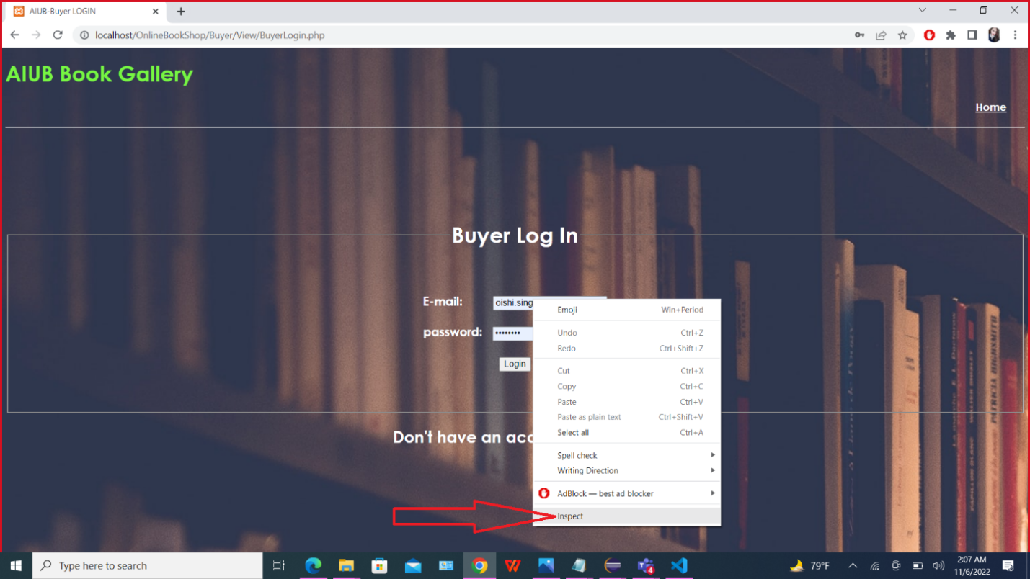

This is for E-mail field.

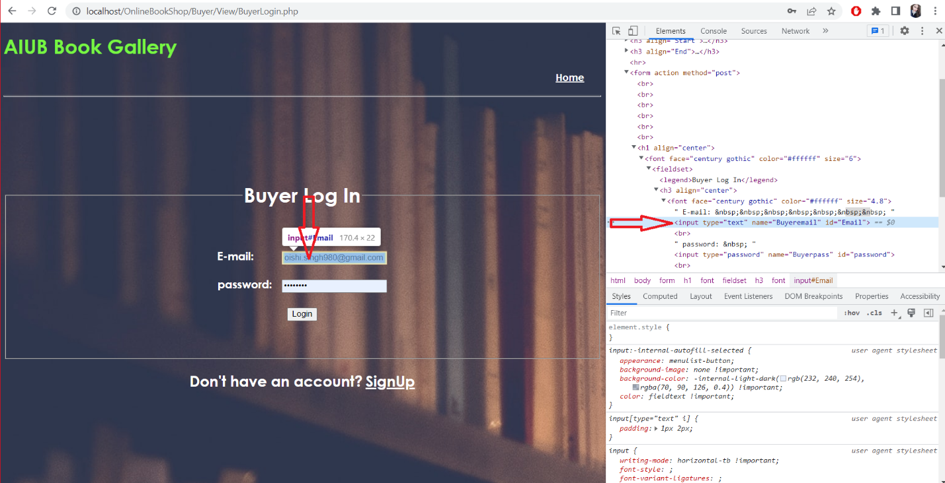

This is for password field.

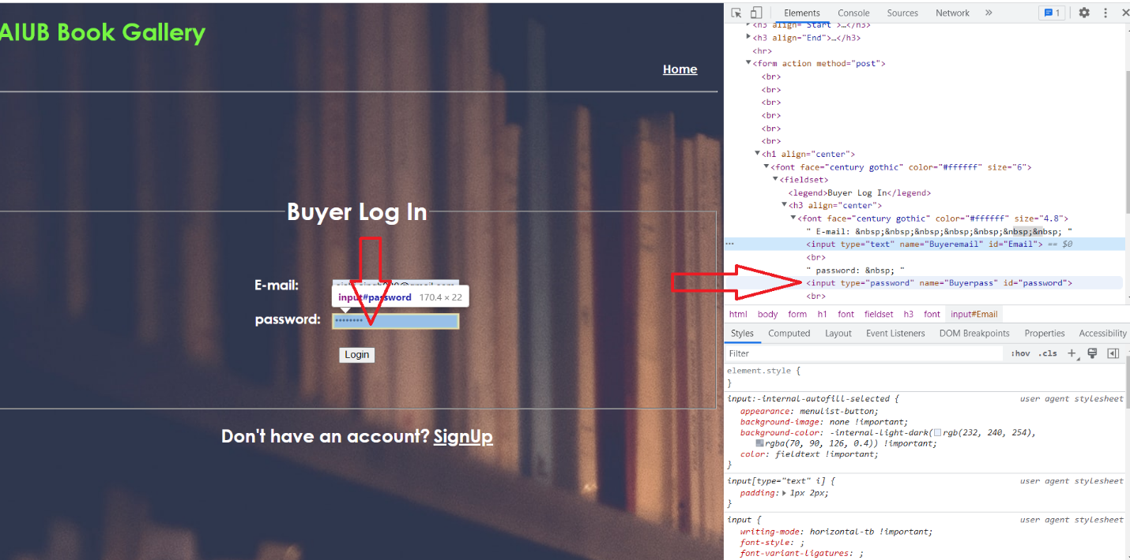

For submit button XPath. Right click on **Submit** button then go to **Inspect.** Then **code block** appears then **right click on that code block t**hen go to **Copy and Copy XPath.**

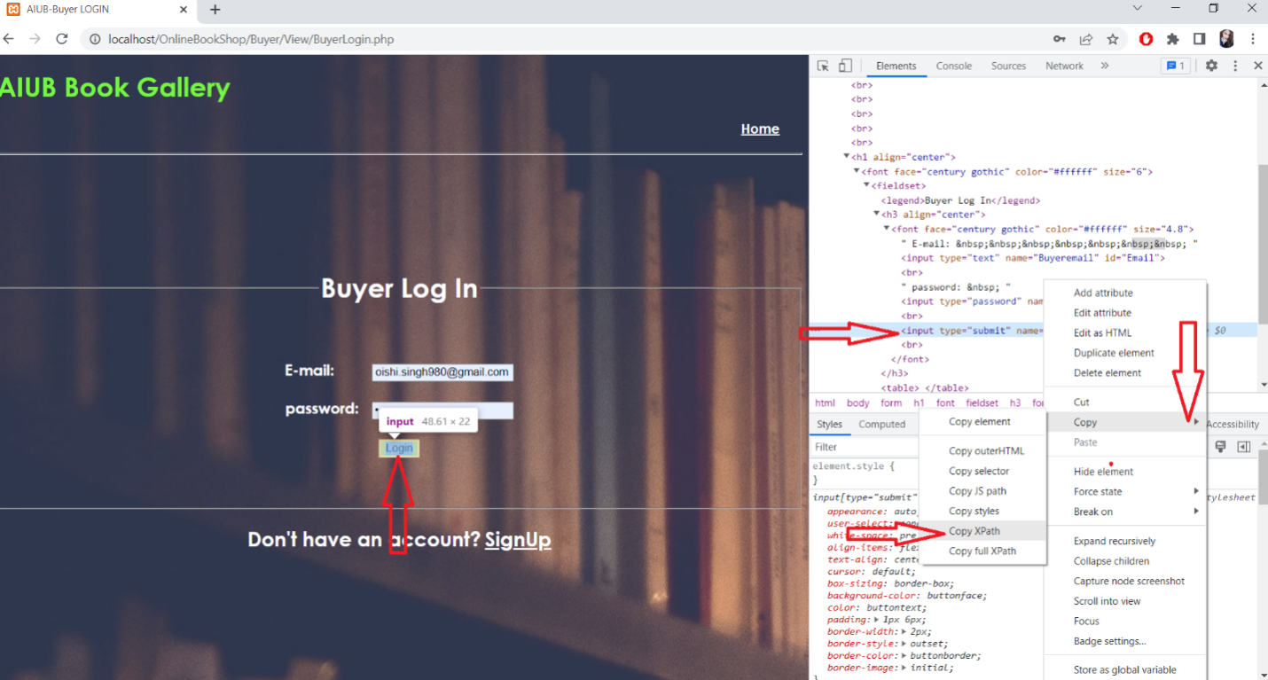

By following these steps, we can easily find out the **E-mail** and **XPath**.

**Run and observe the outcome**

After code written click on the run buttonFor very short time login page appear to us. E-mail, password field will fill- up with respective E-mail and password which defined in testcase and code. Lastly submit button automatically clicked and successfully login into the website. In the Console section of Eclipse IDE “Login Test Successful” text will be appeared. That's mean our testing process is successful.

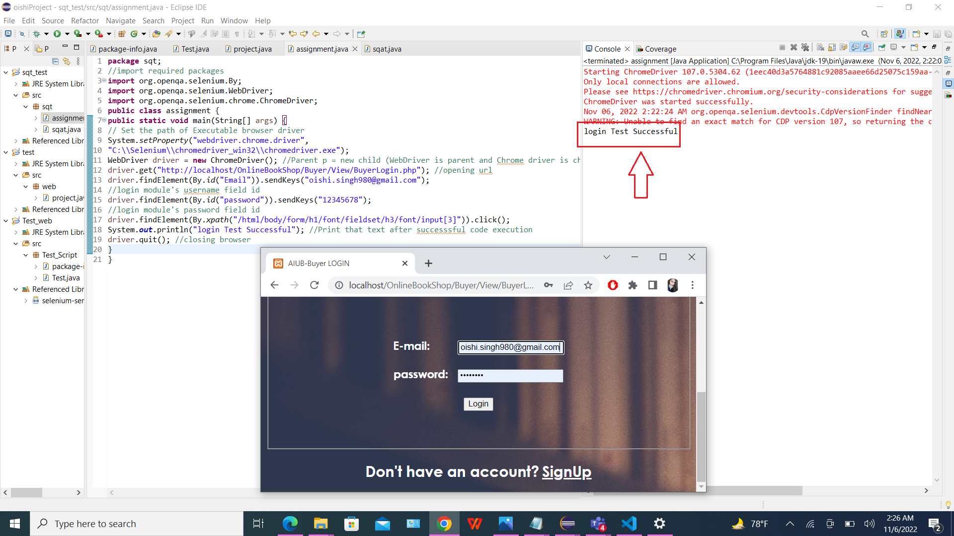

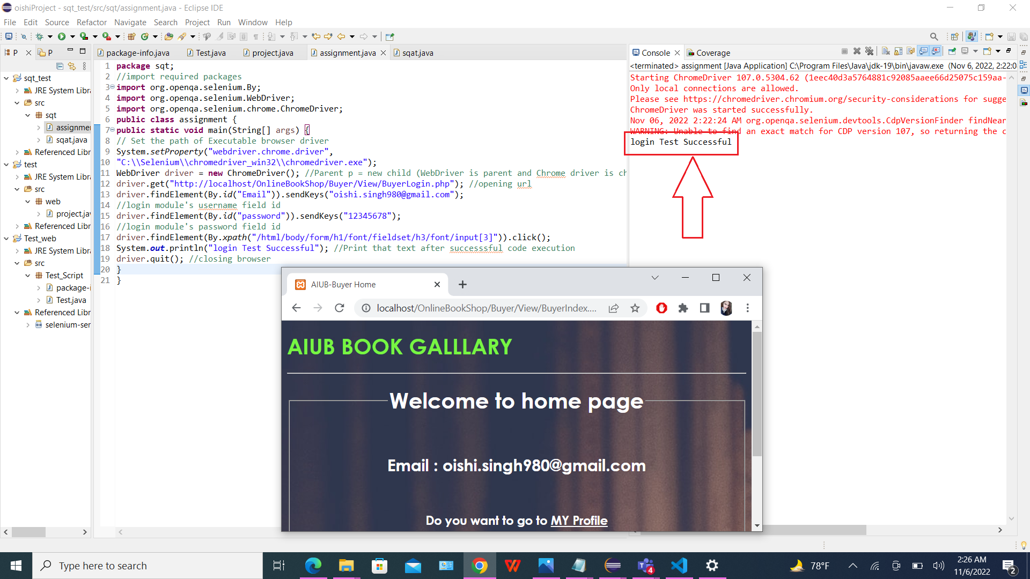

***TEST CASE: (Buyer)***

***This is Buyer Login test case***

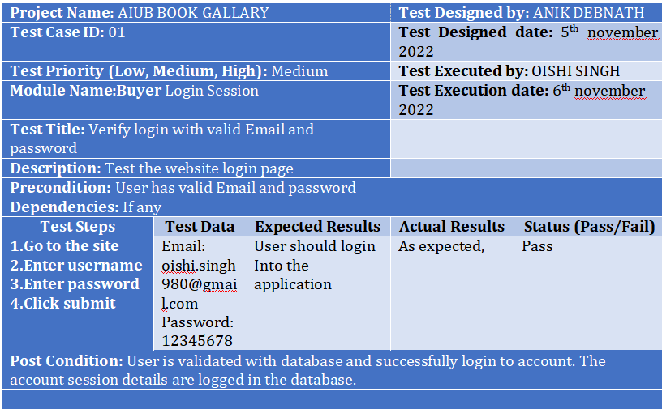

***Second one is Seller Login session:***

**(SELLER PART)**

package sqt;  
//import required packages  
import org.openqa.selenium.By;  
import org.openqa.selenium.WebDriver;  
import org.openqa.selenium.chrome.ChromeDriver;  
public class sqat {  
public static void main(String[] args) {  
// Set the path of Executable browser driver  
System.setProperty("webdriver.chrome.driver",  
"C:\\Selenium\\chromedriver_win32\\chromedriver.exe");  
WebDriver driver = new ChromeDriver(); //Parent p = new child (WebDriver is parent and Chrome driver is child))  
driver.get("[http://localhost/OnlineBookShop/Seller/View/SellerLogin.php");](http://localhost/OnlineBookShop/Seller/View/SellerLogin.php%22);) //opening url  
driver.findElement(By.id("Email")).sendKeys("anik.deb93@gmail.com");  
//login module's E-mail field id  
driver.findElement(By.id("password")).sendKeys("12345678");  
//login module's password field id  
driver.findElement(By.xpath("/html/body/form/h1/font/fieldset/h3/font/input[3]")).click();  
System.out.println("login Test Successful"); //Print that text after successsful code execution  
driver.quit(); //closing browser  
}  
}

***Here we create a new class for seller login session inside sqt package.***

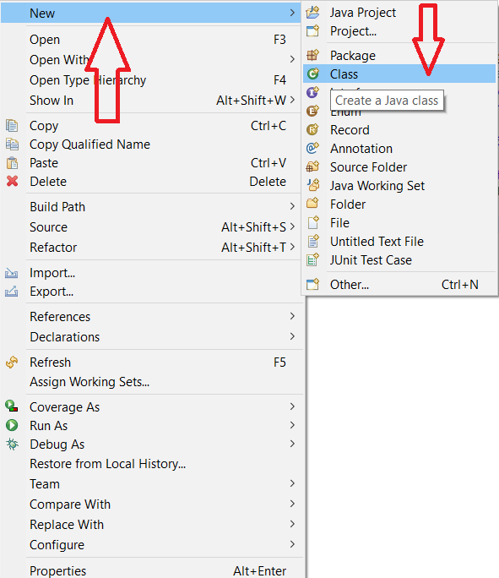

***The name of the class we have opened is sqat. Then we click Finish button.***

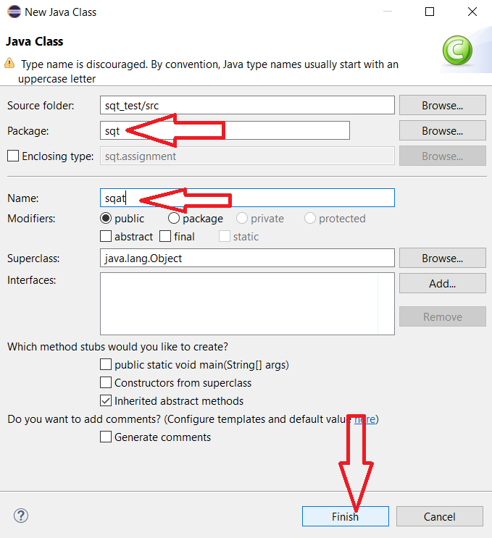

Then, we need to go to the web page. Then select the field (Seller login session) and right-click on that field. Go to Inspect then the respective field code block appears to us and we can easily find the E-mail and copy that. Same process goes for password and login field.

This is for E-mail field.

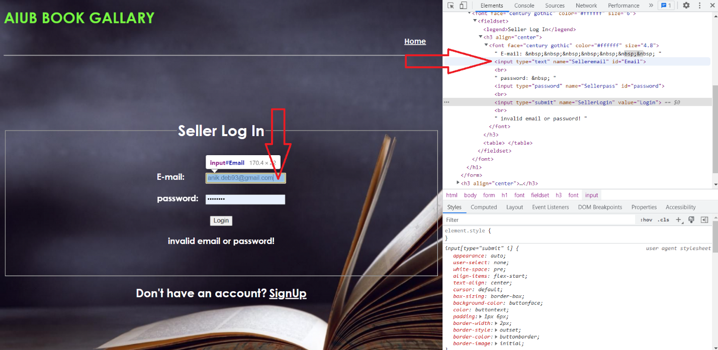

This is for password field.

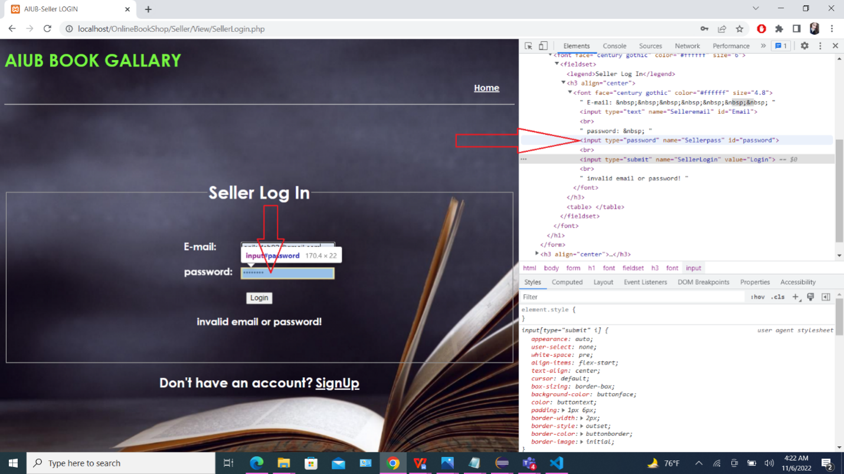

For submit button XPath. Right click on **Submit** button then go to **Inspect.** Then **code block** appears then **right click on that code block t**hen go to **Copy and Copy XPath.**

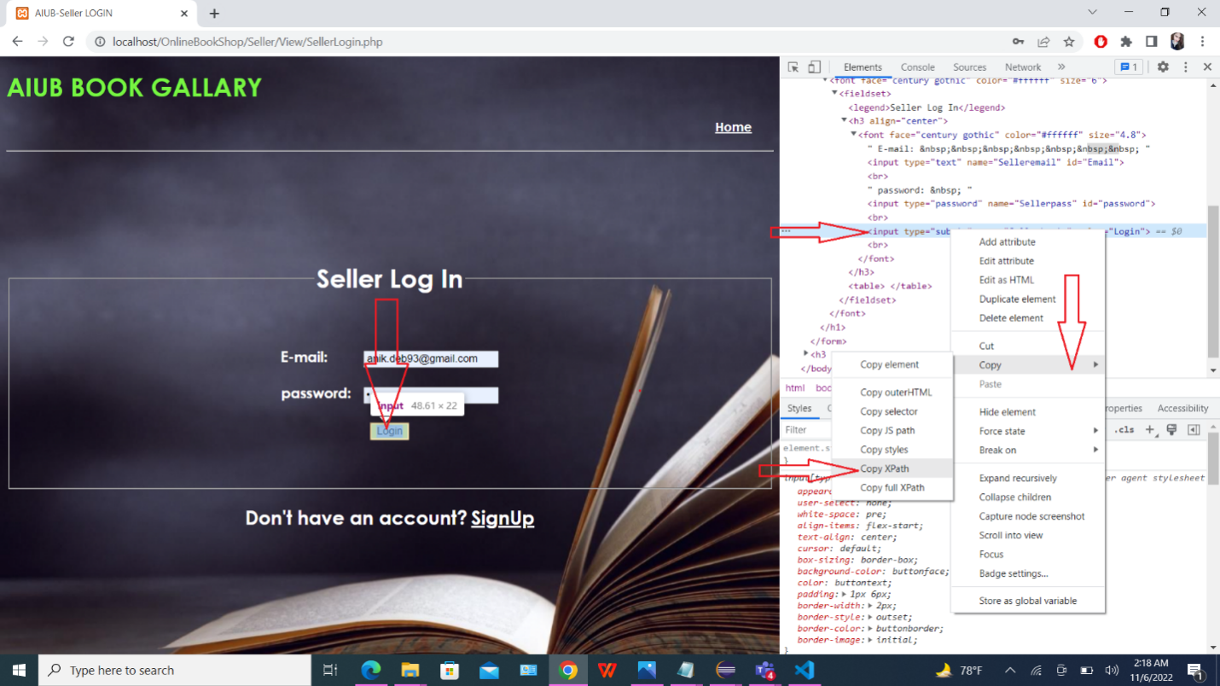

By following these steps, we can easily find out the **E-mail** and **XPath.**

**Run and observe the outcome**

After code written click on the run button. For very short time login page appear to us. E-mail, password field will fill- up with respective E-mail and password which defined in testcase and code. Lastly submit button automatically clicked and successfully login into the website. In the Console section of Eclipse IDE “Login Test Successful” text will be appeared. That's mean our testing process is successful.

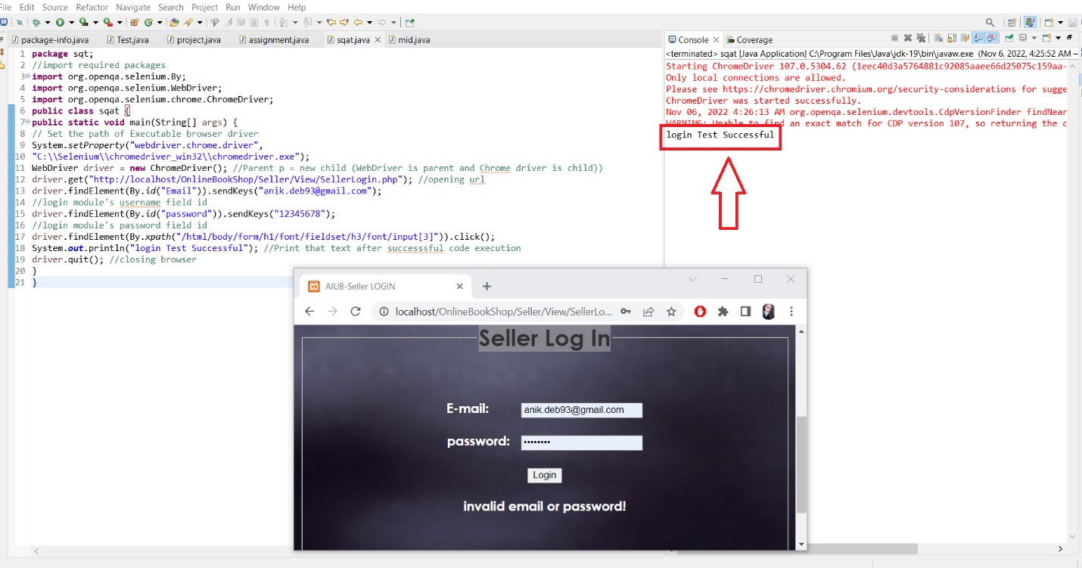

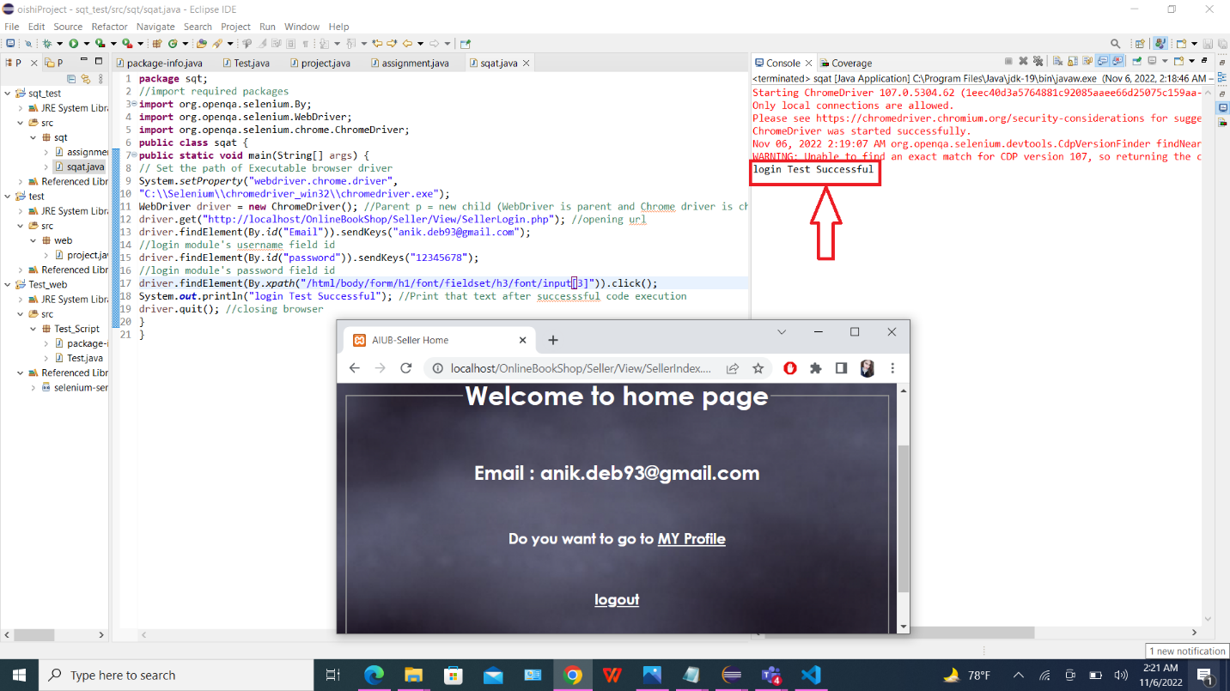

***TEST CASE: (Seller)***

***This is Seller login test case***

